**Signal Conditioner**

**The Narrowband Sensor**

Narrowband sensors are often just called oxygen sensors because for many years this was the only type of oxygen sensor available. It is called a narrow band sensor because it can only detect a very narrow range of AFRs. The function of this sensor is based on an electrochemical cell called a Nernst cell (Figure 1). It is made up of Zirconia, an oxide of Zirconium, and an important property of Zirconia is that it can conduct oxygen ions above a temperature of about 350°C. When the sensor is fitted, the outside of the Zirconia element is exposed to the exhaust gas and the inside is in contact with reference air. Both sides of the element are coated with thin layers of platinum that act as electrodes and carry the sensor voltage from the Zirconia element to the lead wires. At operating temperature, oxygen ions are able to pass through the element and deposit charge on the platinum electrodes thus generating a voltage.

The Narrowband Sensor is basically an on/off switch in that it can determine if the mixture is lean or rich, but it doesn't tell the ECU how lean or how rich the mix is. It communicates with the ECU via the voltage it produces. If the AFR is rich, a HIGH signal voltage is generated across the electrodes due to the difference in oxygen concentration present across the two sides of the element. Conversely, if the AFR is lean, a LOW voltage is generated across the electrodes due to the small difference in oxygen content between exhaust gases and the reference air inside the sensor.

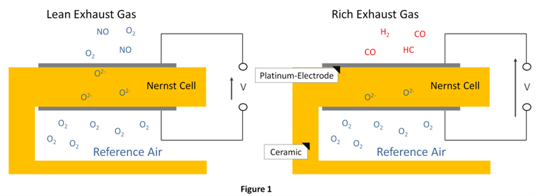

**The Wideband Sensor**

Wideband sensors have an additional ceramic cell (Figure 2).The exhaust gas partially diffuses through the diffusion barrier. The AFR of the exhaust gas in the chamber is measured with the Nernst cell. Depending on whether the AFR in the chamber is rich or lean, a control circuit applies a voltage to the electrodes of the pump cell. Oxygen ions are transported from the inner to the outer electrode so that the AFR in the chamber becomes lambda = 1. The generated electric current, Ip, is the signal. There is a specific range of current corresponding to lambda from 0.7 to infinity. The signal is zero when the AFR of the exhaust gas is lambda = 1. The output curve permits steady control with a predetermined nominal value for lambda.

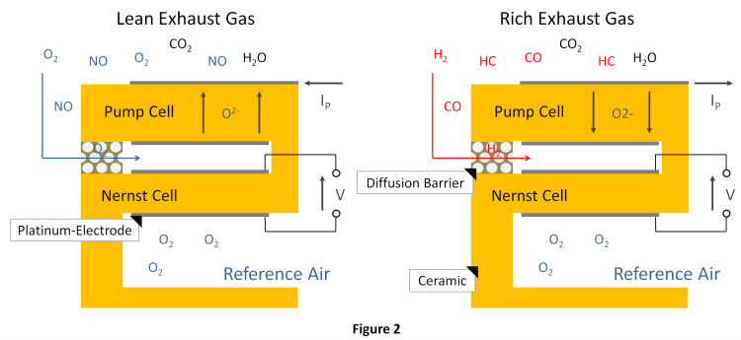

For this the graph of **Ip to Lambda** is also as shown:

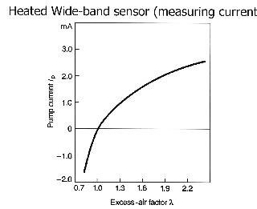

The current signal that can travel in one of two directions (positive or negative). The current signal gradually increases in the positive direction when the air/fuel mixture becomes leaner. At the "stoichiometric" point when the air/fuel mixture is perfectly balanced (14.7 to 1), which is also referred to as "Lambda", the current flow from the sensor stops and there is no current flow in either direction. And when the air/fuel ratio becomes progressively richer, the current reverses course and flows in the negative direction. Sensor's output voltage is converted by its internal circuitry into a variable

Schematic Diagram of Workflow is as follows:

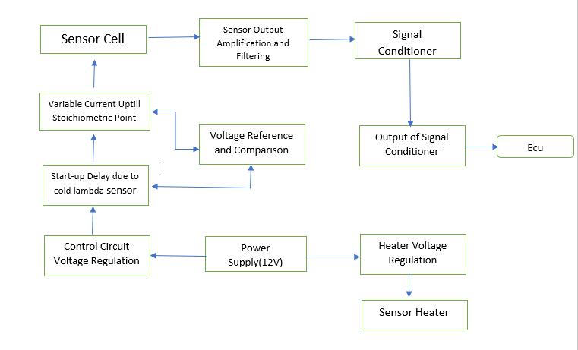

As the ECU requires voltage input but the sensor provides current output, we have to make a signal conditioner which converts the output pump current Ip to a voltage readable by ECU according to this table:

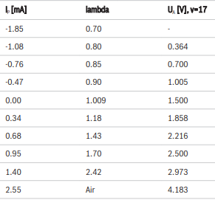

For this the graph of **Ip to Vout** is as shown:

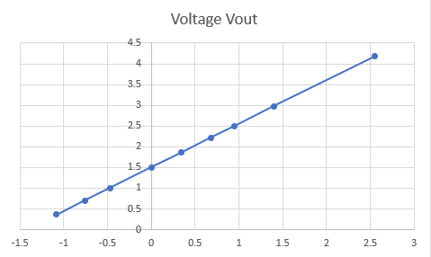

The circuit for implementing the above graph is as shown:

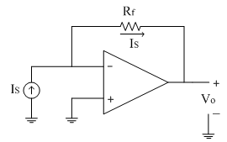

Equations involved for calculating values are:

V=IR + Vdc

Vdc=intersection on y-axis=1.5V

R=m=(y2-y1)/(x2-x1)=(2.500-2.216)/(0.95-0.68)=1.05

Hence R is 1.05kOhm(Since Ip is in mA).

From Graph we can see Vdc will be 1.5V.

Hence circuit for opamp will be:



=1.05kOhmm

Vdc=1.5V

Vout

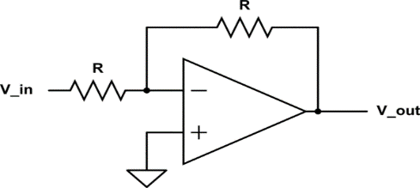

Till now we have achieved two things:

* Linearization of Output
* Amplification to obtain ECU data
* Output Signal which can be fed to filters to obtain final output to ECU

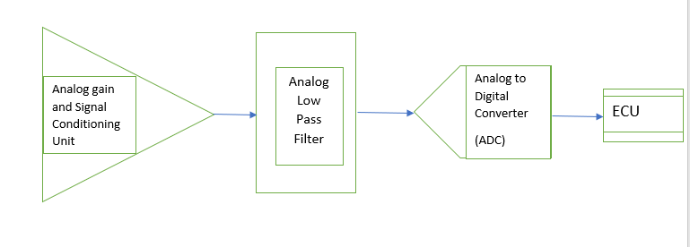Now the output of the above circuit after it is fed to a set of filters after which it is fed to ADC as shown:

Now, we know that the output analog frequency of the wideband sensor ranges from around 4000-4500Hz.Therefore we have to select a filter such that it lets pass this frequency range.

For this we make use of an Anti-Alias Filter (Low-Pass Filter) as shown:

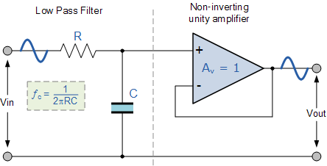

=10kOhm

C=3.536nF

Here the cut-off frequency for the filter is to be around fc=4.5kHz.

Let us assume **R=10kohm.**

Then,

fc=1/(2*pi*R*C)

Substituting and calculating C, we get**, C=3.536nF.**

Now, next we have to sample the frequency so that we can input it to the Analog to Digital Converter.

For sampling the frequency, we use the following circuit using MOSFETs which has a logic pulse controller (Oscillator) at the Gate terminal whose purpose is to switch on and off the MOSFET rapidly in order to sample the output.

The frequency of oscillator can be found out using Nyquist Theorem which states sampling frequency should be greater then or twice the input freq.

Hence, here since the input frequency to the ADC is 4.5kHz, we chose the **sampling rate to be 10kHz.**

The circuit is as shown:

Here **the control gate frequency is set to 10kHZ.**

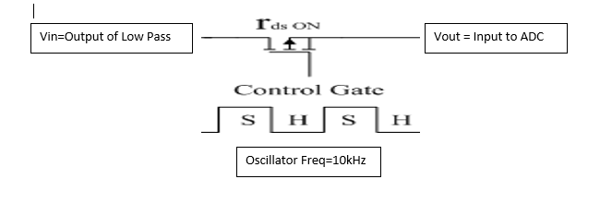

Now, we move on to create an **Analog to Digital Converter**:

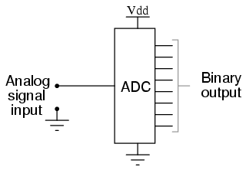

Now this **12-bit** output from A-D converter is fed into an encoder which communicates this information to the ECU as shown**.**

Encoder

**ECU**

**12 Bit Output Data From ADC**